**UCLA Winter 2019**

**ENG 111 Final Exam**

**Mel Bulu Taciroglu**

**Name:_________________________ ID:_______________________**

**~~1.~~** ~~(10 points)~~~~The Hunt Inc. is considering introducing a new product to the market that requires to install a new machine costing $x today with a lifetime of 5 years. Annual fixed cost is $2,800 and the variable cost is $1 per unit. The sale price per unit is $4. Hunt’s tax rate is 34% and its discount rate is 10%. (Assume depreciation is straight-line)~~

*~~(Graders: please do not take off any points for different rounding conventions, i.e., using two digits, one digit, or rounding to a whole number)~~*

**~~a)~~** ~~If the market conditions is such that Hunt can sell 1000 units of this product per year, what should be $x for Hunt to achieve accounting break-even?~~

*~~Accounting Break-Even:~~*

*~~Q=(Fixed Costs+Depr.) / (Sales Price-Var. Cost)~~*

*~~1,000 = (2,800+x/5)/(4-1)~~*

*~~x=1,000~~*

**~~b)~~** ~~What should be $x for Hunt to achieve financial break-even?~~

*~~Financial break-even when interest is 10% :~~* *~~EAC = $x*0.10/(1-1/(1.10~~~~5~~~~)) = $0.2638x~~*

*~~(EAC+Fixed Costs)*(1-t) – t*Depr.) / (Sales Price-Var. Cost)*(1-t)=Q  
= [$0.2638x + $2,800(1 - .34) - $(x/5)(.34)] / [($4 - $1)(1 - .34)] = 1,000 units~~*

*~~x=674.15~~*

**2.** Consider two stocks, A and B, with the following characteristics:

|  |  |  |
| --- | --- | --- |
| Stock | Expected Return(%) | Standard  Devation(%) |
| A | 8 | 21 |
| B | 14 | 44 |

You have $1,000 and you would like to invest on a portfolio formed by A and B.

**a)** (5 points) If A and B were to be perfectly positively correlated, what would be the minimum variance portfolio you could invest on (what would be the weight on A and weight on B) ?

*100% on A and 0% on B.*

**b)** (5 points) If the covariance between the returns of A and B is 0.002, what would be the minimum variance portfolio you could invest on?

*σ = xσ + xσ + 2xAxBCov(A,B)*

*σ = x(0.22)2+ (1-xA2)(0.45)2 + 2xA(1-xA )0.002*

*Take the derivative with respect to xA and equate it to 0 to get:*

*xA = Dear grader: please solve this numerically!*

**c)** (8 points) Now assume that you can also invest and borrow at the risk free rate of 3%. If the maximum return you could get for a risk level (measured by standard deviation) of 50% is 18%, what is the maximum return you could obtain at a risk level of 44%?

*The line that is passing through two points (return, SD) = (3%,0) and (return, SD) = (18%,50%)*

*Is given by r=(18-3)SD/(50-0) + 3. Then if SD is 44 r is 16.2%.*

**3.** (6 points) You invested on a portfolio with expected return of 20% and a standard deviation of 40%. Assuming that the returns follow a normal distribution, with what probability you will at least double your investment next year?

*(Graders: please note that most of the points should be given to the method for this question rather than the exact number)*

*Doubling of investment corresponds to +100% return or more. This corresponds to the half of the probability of rate being outside of the range of the two standard deviations:*

*20%+40%*2 = +100%*

*The probability is (1-99%)/2 = 0.05%.*

**4.** **a)** (3 points) What should be the optimum retention ratio for a zero growth company?

*b: retention ratio*

*Stock price for a zero growth company is P=Div/R = (1-b)EPS/R*

*As b increases P falls, therefore optimum b=0.*

**b)** (3 points) What should be the optimum retention ratio for a constant growth company with an ROE of 0.6 when the market rate is 17%

*Stock price for a constant growth company is P=Div/(R-g) = (1-b)EPS/(R-b.ROE)*

*Taking the derivative w.r.to b gives us an increasing price with increased b, only when ROE>R.*

*Since 0.6 > 0.17, optimum b for this company is 1.*

**5.** **a)** (3 points) What is a YIELD CURVE?

*The relation between the maturity and the yield of treasury bonds.*

**b)** (5 points) Why would the yield curve be inverted?

*High demand for long term bonds and low demand of short term bonds. Observed prior to ressions.*

**6.** (12 points) Consider a 10-year bond that has $100 coupon and $1,000 face value. Assume that the market rate stays the same at rate r% throughout the life of this bond. Right after its 8th coupon payment (on the same day as the coupon payment) the capital gains on this bond is 1.65% (i.e., capital gains from year 8 to year 9). At this time, the bond is selling for $966. What was the current yield on this bond right after its first coupon payment in year 1?

*Price in year 9 = 966*1.065 = 982*

*982 = 1100/(1+r)*

*r = 12%*

*Price in year 1 right after the first coupon payment = 100 (1/1.12 + 1/1.122 + ..+1/1.129) + 1000/1.129 = 893*

*Current yield at this time = 100/893 = 11.2%*

**7.** (10 points) There are two bonds, A and B, that are being issued today, each with a Face value of $1,000, coupon rate of 10%, and a maturity of 2 years. A has a promised yield of 12% and B has a promised yield of 15%. B has a default rate that is 10% higher than that of A’s. Market expects a haircut of 50% on the coupons and the face value in case of a default for each bond.

There is another two-year bond that is issued today with no default probability. This bond also has a 10% coupon rate and $1,000 face value. What is the price of this bond today? (You do NOT need the quadratic formula to solve this question)

*Price of A = 100/1.12+110/1.122 = 966.2*

*Price of B = 100/1.15+110/1.152 = 918.71*

*pA(50/(1+r) +550/(1+r)2)+ (1-pA) (100/(1+r) +1,100/(1+r)2) = 966.2*

*pB(50/(1+r) +550/(1+r)2)+ (1-pB) (100/(1+r) +1,100/(1+r)2) = 918.71*

**8.** (6 points) Sniurb, Inc. is a young start-up. It is estimated that the company will not be paying any dividends for the coming 8 years. The company is expected to pay dividends of $4.5 a share at year 9 and will increase the dividends at 5.5% per year thereafter. If the rate that can be applied to such a company is 13%, what is the current stock price?

*Here we have a stock that pays no dividends for 8 years. Once the stock begins paying dividends, it will have a constant growth rate of dividends. We can use the constant growth model at that point. It is important to remember that general form of the constant dividend growth formula is:*

*Pt = [Dt × (1 + g)] / (R – g)*

*This means that since we will use the dividend in Year 9, we will be finding the stock price in Year 8. The dividend growth model is similar the PV of a perpetuity: The equation gives you the PV one period before the first payment. So, the price of the stock in Year 8 will be:*

*P8 = D9 / (R – g) = $4.50 / (.13 – .055) = $60.00*

*The price of the stock today is simply the PV of the stock price in the future. We simply discount the future stock price at the required return. The price of the stock today will be:*

*P0 = $60.00 / 1.138 = $22.57*

**9.** (6 points) Assume that risk level is represented by the standard deviation. What is the maximum expected return you can get if you can invest on all the portfolios whose expected returns and standard deviations form the following opportunity set (the line marked by A and B) where P* represents the optimal portfolio and Rf denotes the risk free ratewith

Rf = 2%, E(P*) = 8%, σP* = 11%:

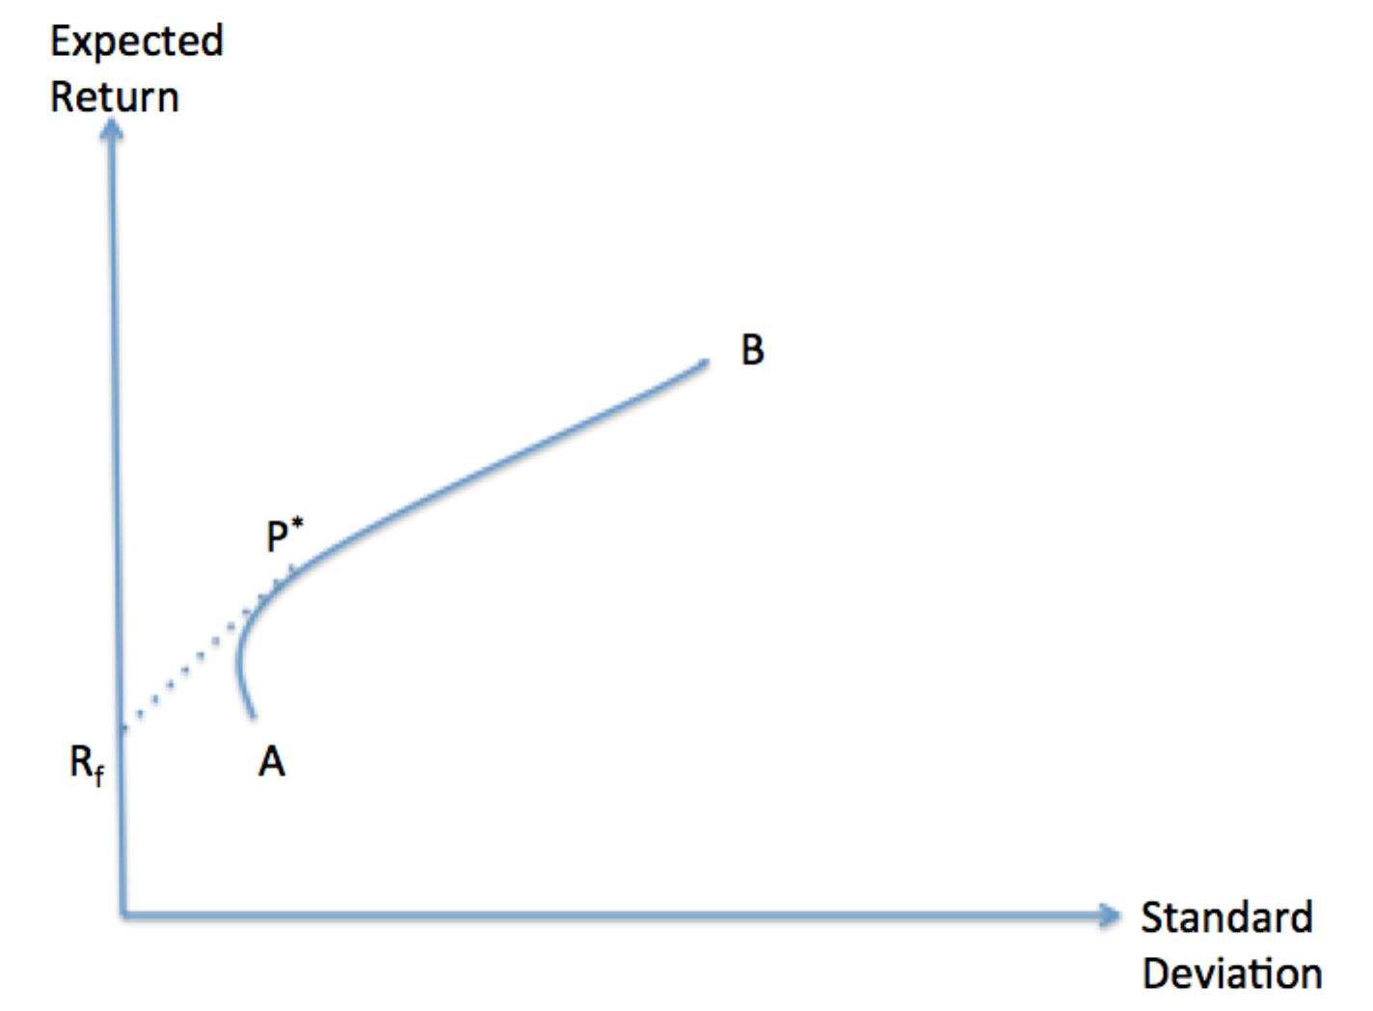

a) If you can bear a risk as much as the optimal portfolio?

*From the graph, we can deduce that P* is the optimal portfolio. Then, with a risk level of σP* = 11%, the maximum return we can get is E(P*) = 8%. 1 point*

b) If you can bear a risk of σ= 15% ?

*0.15 = XP* σP*, XP*=1.36, that is we should invest 136% on P* and -36% on the risk-free asset.*

*That is we should invest all out money on P*, plus, we should borrow as much as 36% more and invest that on P* as well.*

*Expected Return = 1.36 * 8% - 0.36 * 2% = 10.16% 2 points*

*(More explanation: Let F denote the risk-free asset. We are looking for a portfolio that is composed of P* and the risk-free asset whose variance is 0.152 = 0.0225*

*0.0225 = XP* 2 σP*2 +2 σP* σF Cov(P*,F) + XF 2 σF2*

*Here, the second and the third terms on the right hand side are zero.*

c) When would the standard deviation be an inferior representation of the risk level of an asset?

*If we hold a well-diversified portfolio (big enough portfolio to eliminate the unsystematic (idiosyncratic) risk, the risk level each asset presents is measured by asset’s beta, not by its standard deviation.*

**Multiple Choice (3 points each):**

**10.**You are considering a project with the following data:  
  
Profitability index: 0.98  
Net present value: -$393  
Payback period: 2.44 years  
Market rate: 9.5%

Which one of the following is correct given this information?

A. The discount rate used in computing the net present value must have been less than 8.7%.  
B. The discounted payback period will have to be less than 2.44 years.  
C. The discount rate used to compute the profitability index was equal to the rate that makes NPV zero.  
D. This project should be rejected based on the profitability index.  
E. None of the above.

**11.**The cash flows of a new project that come at the expense of a firm's existing projects are called:   
A. salvage value expenses.  
B. net working capital expenses.  
C. sunk costs.  
D. opportunity costs.  
E. erosion costs.

**12.**Which of the following should be included in the analysis of a project?

I. sunk costs  
II. opportunity costs  
III. erosion costs  
IV. incremental costs

A. I and II only  
B. III and IV only  
C. II and IV only  
D. II, III, and IV only  
E. I, II, and IV only

**13.**Wilbert's, Inc. paid $90,000, in cash, for a piece of equipment three years ago. Last year, the company spent $10,000 to update the equipment with the latest technology. The company no longer uses this equipment in its current operations and has received an offer of $50,000 from a firm who would like to purchase it. Wilbert's is debating whether to sell the equipment or to expand its operations such that the equipment can be used. When evaluating the expansion option, what value, if any, should Wilbert's assign to this equipment as an initial cost of the project?

A. $40,000  
B. $50,000  
C. $60,000  
D. $80,000  
E. $90,000

**14.**A project will increase sales by $60,000 and cash expenses by $51,000 annually. The project will cost $40,000 and will be depreciated using straight-line depreciation to a zero book value over the 4-year life of the project. The company has a marginal tax rate of 35%. What is the annual operating cash flow of the project?

A. $5,850  
B. $8,650  
C. $9,350  
D. $9,700  
E. $10,350

**15.** Katelyn's Kites has net income of $240 and total equity of $2,000. The debt-equity ratio is 1.0 and the retention ratio is 40%. What is the internal growth rate?

A. 2.46%  
B. 3.00%  
C. 4.92%  
D. 5.88%  
E. 6.00%

|  |  |
| --- | --- |
| **Market Value Measures** | Market Capitalization = Price per share * # Shares Outstanding  P/E Ratio = Price Per Share / Earnings Per Share  Market to Book Ratio = Market Value per Share / Book Value per Share  Enterprise Value = Market Capitalization + Market Value of Interest Bearing Debts – Cash  EV Multiple = EV/ EBIDTA |
| **External Financing Formulas** |  |
| **Present Value Formulas** |  |
| **Accounting Ratios** | Current Ratio = Current Assets/ Current Liabilities  Quick Ratio = (Current Assets – Inventory) / Current Liabilities  Cash Ratio = Cash / Current Liabilities  Total Debt Ratio = (Total Assets – Total Equity ) / Total Assets  Debt/Equity = Total Debt / Total Equities  Equity Multiplier = Total Assets / Total Equity  Times Interest Earned = (Earnings Before Interest And Taxes) / Interest  Cash Coverage = (EBIT + Depreciation + Amortization) / Interest  Inventory Turnover = Cost of Goods Sold / Inventory  Days’ Sales in Inventory = 365 / (Inventory Turnover)  Receivables Turnover = Sales / Accounts Receivable  Days’ Sales in Receivables = 365 / Receivables Turnover  Total Asset Turnover = Sales /Total Assets  Profit Margin = Net Income / Sales  Return on Assets = Net Income / Total Assets  Return on Equity = Net Income / Total Equity  EBITDA Margin = EBITDA / Sales  Capital Intensity = Total Assets / Sales |
| **Break Even Point** | Accounting: (Fixed Costs+Depr.)/(Sales Price-Variable Cost)  Financial(Pres. Value): (EAC+Fixed Costs*(1-t) – t*Depr.) / (Sales Price-Var. Cost)*(1-t) |
| **Bond Value** |  |
| **Stock Valuation** | Zero Growth: Constant Growth: Differential Growth: |
| **Stock Returns** | Holding Period Return: Arithmetic Average Return: |
| **Sample Statistics** | Corr(A,B) = $ρ_{A,B}= \frac{σ_{A,B}}{σ_{A}σ_{B}}$ |
| **Portfolio Analysis** | Expected Return on Portfolio:    Variance of a portfolio: |